Name Classification Using PyTorch's

Introduction
Name classification is the process of determining the linguistic origin of a given name. This technique is widely used in natural language processing (NLP) applications, such as identity verification, demographic analysis, and recommendation systems. The dataset used in this project contains names from 18 different languages, sourced from PyTorch's official tutorial. The objective is to classify names into their respective language categories based on character patterns.
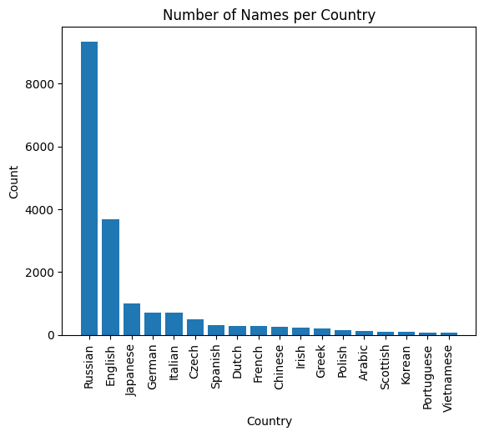

Dataset Overview
The dataset consists of names categorized into different text files, each representing a specific language. The key characteristics of the dataset include:
- Languages Covered: Arabic, Chinese, Czech, Dutch, English, French, German, Greek, Irish, Italian, Japanese, Korean, Polish, Portuguese, Russian, Scottish, Spanish, and Vietnamese.
- Data Source: Kaggle repository containing text files with names grouped by language.
- Data Representation: Each name is stored as a string, with its corresponding language label.
- Name Count Bargraph: A bar graph is used to visualize the count of names for each language category, providing insights into the dataset distribution.

Dataset Link
- Kaggle Dataset: Name Classification

Data Preprocessing
Before training a model, the dataset undergoes a series of preprocessing steps to ensure consistency and usability. The main steps include:
- Loading Data: Text files are read and converted into a structured format, typically a Pandas DataFrame.
- Data Cleaning: Unwanted characters, special symbols, and accents are removed using Unicode normalization.
- Encoding Labels: Since machine learning models require numerical inputs, language labels are encoded into numerical representations using label encoding.
- Feature Extraction: Names are converted into vector representations suitable for training a machine learning model. This can be done using techniques such as one-hot encoding, character-level embeddings, or n-grams.

Model Selection and Training
This project implements a Recurrent Neural Network (RNN) using PyTorch to classify names based on their character sequences. The key aspects of the model include:
- RNN Architecture: The model consists of an embedding layer, recurrent layers (such as LSTM or GRU), and a fully connected output layer.
- Training Process: The dataset is split into training and testing sets, and the model is trained using an appropriate optimizer, such as Adam, to minimize classification errors.
- Loss Function: Cross-entropy loss is used to measure the difference between predicted and actual classifications.
- Saving Model Weights: After training, the model's weights are saved using PyTorch’s torch.save() function, allowing for reuse and deployment without retraining.

Application and Deployment
Once the model achieves satisfactory performance, it is deployed for real-world applications through a Streamlit web application and hosted on Hugging Face Spaces. The deployment process involves:
- Creating a Streamlit App: A user-friendly interface is developed using Streamlit, where users can input a name and get the predicted language classification.
- Loading Model Weights: The saved model weights are loaded using torch.load() to make real-time predictions.
- Deployment on Hugging Face Spaces: The Streamlit app is containerized and deployed on Hugging Face Spaces for public access, ensuring accessibility and scalability.

Application Link
- Hugging Face Spaces: Name Classification

Conclusion
Name classification is a useful application of NLP and machine learning, providing insights into the linguistic structure of names. This project demonstrates how to preprocess text data, train machine learning models, save model weights, and deploy a Streamlit-based application on Hugging Face Spaces. Future improvements could involve expanding the dataset, incorporating advanced deep learning architectures, and optimizing model deployment for faster predictions.

