ML – Based Insurance Cost Prediction

Project Title: Insurance Cost Prediction using Machine Learning and Streamlit
Objective:
To develop a machine learning model to predict health insurance costs based on various customer attributes and deploy it as an interactive web application using Streamlit.
Problem Statement:
Accurately predicting health insurance costs is crucial for both insurance companies and customers. Understanding the factors influencing these costs allows for better pricing strategies and informed decision-making.
Proposed Solution:
Develop a machine learning model to predict insurance charges based on factors like age, BMI, smoking status, number of children, and region. Deploy this model as a user-friendly Streamlit application for real-time predictions and interactive data visualization.
Dataset Description:
The dataset contains information on various features including age, sex, BMI, number of children, smoking status, region, and insurance charges.
Methodology:
- Data Preprocessing: This involved handling missing values (details not specified), encoding categorical variables (sex, smoker, region) using techniques like one-hot encoding or label encoding, and scaling numerical features as needed.
- Exploratory Data Analysis (EDA): EDA included distribution analysis (histograms, boxplots), bar graph analysis of categorical variables, correlation analysis using a heatmap, examining the impact of smoking on charges using boxplots, and analyzing regional variations in insurance charges.
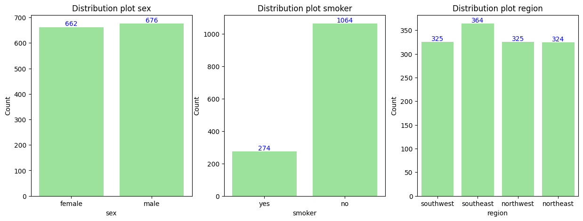
- Model Design: Three regression models were used:
  - Linear Regression (baseline)
  - Random Forest Regressor
  - Decision Tree Regressor
Tools and Technologies:
- Python
- Scikit-learn (for machine learning models)
- Streamlit (for web application development)
- Hugging Face Spaces (for application deployment)
Evaluation Metrics:
For evalution this methods are need Mean Squared Error (MSE),Mean Squared Error (RMSE),R-squared (R²) score,Adjusted R-squared (R²) score
Model | RMSE | MAE | R² | Adjusted R²
LR | 5799.59 | 4186.51 | 0.7086 | 0.7019
DT | 6713.13 | 3043.19 | 0.7541 | 0.7484
RF | 4635.53 | 2534.29 | 0.8534 | 0.8500

Results & Analysis:
The specific performance metrics (MSE, RMSE, R², Adjusted R²) for each model are from the provided in above table .
Application Deployment:
The Streamlit application is deployed on Hugging Face Spaces and is publicly accessible
App link :- https://huggingface.co/spaces/YAMITEK/Insurance-Analysis
Key Insights & Recommendations:
- Smoking significantly increases insurance costs.
- Higher BMI is correlated with higher charges.
- Region and non-smoking status influence insurance costs.
- Age is a significant factor in determining premiums.
Future Scope:
- The document does not explicitly state future scope, but potential improvements include more detailed hyperparameter tuning, exploration of additional models, and incorporation of more features.
Conclusion: The project successfully developed a machine learning model for predicting insurance costs and deployed it as an interactive Streamlit application. The analysis revealed key factors influencing insurance charges, providing valuable insights for both insurance companies and customers.
References:
- Kagale Data: https://www.kaggle.com/datasets/willianoliveiragibin/healthcare-insurance/data
- Hugging face hub
- Streamlit documentation

